How many total hours and miles logged by each driver?

SELECT d.driverId,

SUM(t.hourslogged) as total_hours,

SUM(t.mileslogged) as total_miles

FROM drivers d

JOIN timesheet t ON d.driverId = t.driverId

GROUP BY d.driverId;

Print the name of the driver in the above query

select d.name,

sum(t.hourslogged) as total_hours,

sum(t.mileslogged) as total_miles

from drivers d

join timesheet t ON d.driverId = t.driverId

Group By d.name;

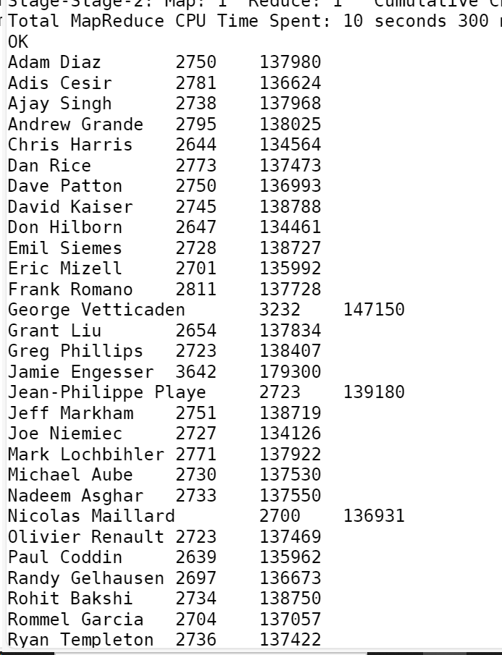

Write the above query output in to hdfs director:

INSERT OVERWRITE LOCAL DIRECTORY '/home/mavricbdhnov0114/'

ROW FORMAT DELIMITED FIELDS TERMINATED BY ','

select d.name,

sum(t.hourslogged) as total_hours,

sum(t.mileslogged) as total_miles

from drivers d

join timesheet t ON d.driverId = t.driverId

Group By d.name;

INSERT OVERWRITE LOCAL DIRECTORY '/user/$USER/workspace'

ROW FORMAT DELIMITED FIELDS TERMINATED BY ','

select d.name,

sum(t.hourslogged) as total_hours,

sum(t.mileslogged) as total_miles

from drivers d

join timesheet t ON d.driverId = t.driverId

Group By d.name;

